**Outline**

Develop a better understanding of procedural sequencing by solving shape drawing challenges using the turtle environment.

**Objectives**

* Use correct terminology to describe programming concepts;
* Describe the types of data that computers can process and store (e.g., numbers, text);
* Explain the difference between constants and variables used in programming;
* Use variables, expressions, and assignment statements to store and manipulate numbers and text in a program

**Materials**

* Python Turtle Development Environment at: https://repl.it/
* PythonWorksheetII form the GitHub Repository
* Web links identified in the questions below

**Level 1: Drawing Basic Shapes With Python Turtle**

1. Open the document PythonWorksheetII from the class GItHub repository.   
   Read over “Part III” at the end of the PythonWorksheetII document.
2. Create an new Repl by selecting the “Python with Turtle” language / environment.
3. Begin all of your turtle programs with the following code to create a “pen”:

import turtle

myPen = turtle.Turtle()

1. Create a program to draw a red circle.
   1. Provide a listing of your program code below:

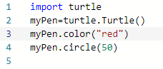

1. Create a program to draw any three of the shapes described in “Part III” of   
   the PythonWorksheetII document.
   1. Provide a listing of your program code below:

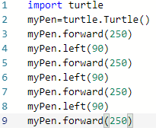

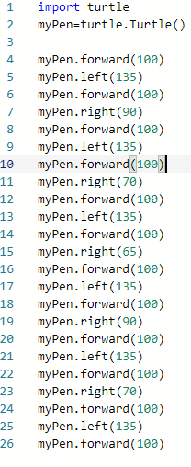

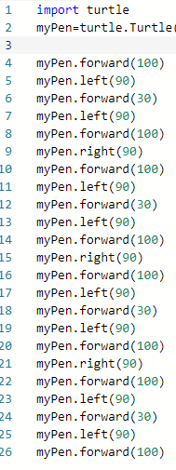

**Level 2: Using a Loop**

1. Google the keywords “Python Turtle Methods”.
   1. Explain how the “goto” method works and how you could use it when drawing repeated shapes.

The “goto” method is used to move the objects in different directions instead of the object just being created on the same place. This can be used for drawing repeated shapes as it can move in different directions to make a different looking image.

* 1. List some other useful methods not listed in “Part III” at the end of the PythonWorksheetII document.

Other important methods which are not listed in Part 3 is:

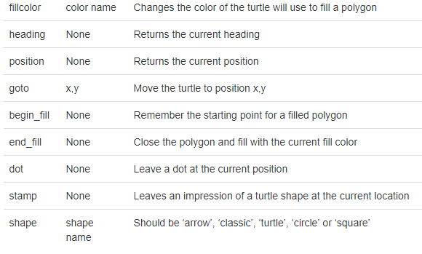

1. Create a repeating pattern on your screen. The pattern must meet the following requirements:
   1. The basic pattern must be made up of several individual Turtle methods (e.g. changes of colour, changes of direction, size, motion, etc.)
   2. The basic pattern must be repeated several times with a shift in starting position each time.

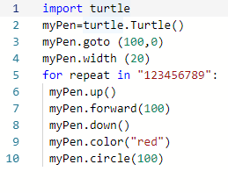

1. Use a Python Loop to create your repeating pattern
   1. The Loop may be a Counted Loop or a Conditional Loop
   2. The indented block of code for the loop should be your basic pattern.
2. Provide a listing of your repeating pattern loop below.

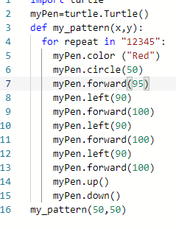

**Level 3: Defining a Function**

1. Google the keywords “Python Function Syntax”.
   1. Explain what the “def” keyword does

**Makes the start of function header.**

* 1. Explain any special rules regarding the function name

**It needs a name to uniquely identify it, which is the same rules as python.**

* 1. Explain what the parameters (or arguments) do

**Parameters (arguments) through which we can pass values to any function. These are optional in Python.**

* 1. Where should the colon “:” be placed

**At the end of the function’s header.**

* 1. Explain how to write Python statements that make up the function body

**One or more valid statements that have the same indentational level.**

* 1. Explain the “return” statement

**Used to return a value from the function**

1. Provide an example of a simple function that uses one or more parameters.
   1. Write the function definition below

**“”docstring””**

**Statements(s)**

* 1. Write some code to call the function below

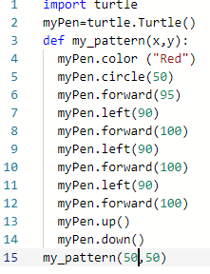

1. Convert your basic pattern (from Level 2 above) into a function
2. The function name should be “my_pattern”
3. The parameters should be the x and y starting position for your pattern
4. Your function does not need to use the “return” statement



1. Use a your basic pattern function and a Python Loop to create your repeating pattern
   1. The Loop may be a Counted Loop or a Conditional Loop
   2. Your function should be called from within the loop.
2. Provide a listing of your function definition and repeating pattern loop below.

